9 SCIENCE 2015

PHYSICS TEST ONE

Name: ____________________ Teacher: ___________________ Mark: /46

Percentage: %

SECTION A: MULTIPLE CHOICE (15 marks)

Select the most correct answer for each question below.

1. Letter A in the diagram below represents:
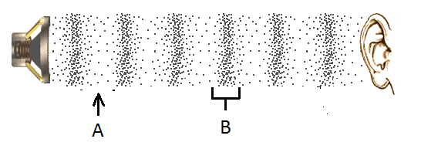

(a) Compression.
(b) Sound wave.
(c) Refraction.
(d) Rarefaction.

2. Choose the correct definition for ‘frequency’.

(a) Closely packed particles vibrating in a region.
(b) The number of waves passing a point every second.
(c) The distance from one peak of a wave to the next.
(d) The number of waves passing a point every minute.

3. Sound travels the fastest through:

(a) Gas.
(b) Steam.
(c) Liquid.
(d) Solid.

4. Choose the correct definition for ‘conduction’.

(a) Transfer of heat in a liquid or gas due to less dense, warmer matter rising and denser, cooler matter falling.
(b) A method of heat transfer where heat is passed through the vibration of particles.
(c) Movement of heat in the form of electromagnetic waves.
(d) A substance that allows heat to pass through it.
5. Choose the correct definition for ‘heat’.

(a) A form of energy that describes the total movement of all particles within an object.
(b) The measure of how quickly the particles in a material are moving.
(c) The average kinetic energy of particles in a material.
(d) A method of heat transfer.

6. Choose the correct statement about sea breezes.

(a) Air cools and drops down on the land from over the ocean.
(b) A sea breeze occurs during the day.
(c) Warm air rises up from over the ocean.
(d) A sea breeze occurs at night.

7. Choose the correct definition for ‘radiation’.

(a) Movement of heat by electromagnetic waves.
(b) A material that does not conduct heat.
(c) A method of heat transfer where heat is passed through the vibration of particles.
(d) Transfer of heat in a liquid or gas due to less dense, warmer matter rising and denser, cooler matter falling.

8. Choose the correct definition for ‘temperature’.

(a) A measure of the average kinetic energy of particles in a substance.
(b) An instrument used to measure temperature.
(c) A measure of the average potential energy of particles in a substance.
(d) A measure of the heat in a substance.

9. Choose the correct definition for ‘wavelength’.

(a) The number of waves passing a point every second.
(b) The sensation of frequency.
(c) The distance from one peak of a wave to the next.
(d) The number of hertz in a wave.

10. The length of time a sound is heard is known as:

(a) Reverberation.
(b) Echo.
(c) Vibration.
(d) Frequency.

11. Choose the material that would have the slowest speed of sound.

(a) Steel.
(b) Air (at 0°C).
(c) Water.
(d) Glass.

12. Select the ending for the following sentence. Soft materials:

(a) Reflect sound.
(b) Absorb sound.
(c) Transmit sound.
(d) Increase echo in a room.

13. Choose the correct function of the ossicles.

(a) Three tiny bones that transmit vibrations to the cochlear.
(b) Filled with fluid and gives us our sense of balance.
(c) Has hairs to trap dust and dirt.
(d) Funnels sound into the ear canal.

14. Choose the correct function of the semicircular canals.

(a) Carries electrical impulses to the brain.
(b) Filled with fluid, has hairs that pick up vibrations and converts them into electrical impulses.
(c) Filled with fluid and gives us our sense of balance.
(d) Funnels sound into the ear canal.

15. Choose the correct function of the cochlea.

(a) Has hairs to trap dust and dirt.
(b) Carries electrical impulses to the brain.
(c) Filled with fluid, has hairs that pick up vibrations and converts them into electrical impulses.
(d) Three tiny bones that magnify vibrations.

SECTION B: SHORT ANSWER (32 marks)

1. Label the diagram of the ear below. (8 marks)
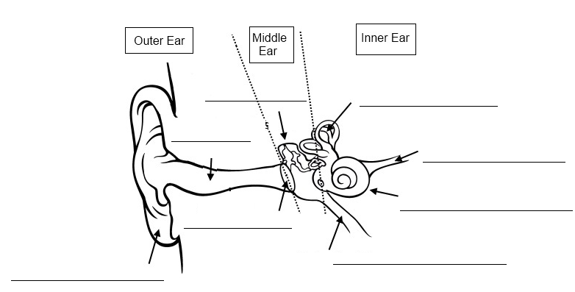

2. Fill in the table below. (3 marks)
Beryllium

Part of ear | Function
Pinna | _______________________________________________________________________  _______________________________________________________________________  _______________________________________________________________________
Eustachian  tube | _______________________________________________________________________  _______________________________________________________________________  _______________________________________________________________________
Auditory  nerve | _______________________________________________________________________  _______________________________________________________________________  _______________________________________________________________________

3. List the three ways that heat can be transferred (moved). (3 marks)

_____________________________________________________________________________________

_____________________________________________________________________________________

4. State the name of an animal that uses ultrasounds. (1 mark)

_____________________________________________________________________________________

5. State the name of an animal that uses infrasounds. (1 mark)

_____________________________________________________________________________________

6. Explain how the group of instruments below produce sound. (2 marks)
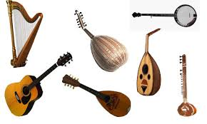

_____________________________________________________________________________________

_____________________________________________________________________________________

_____________________________________________________________________________________

_____________________________________________________________________________________

7. Explain how the group of instruments below produce sound. (2 marks)
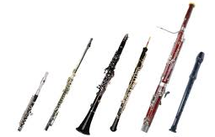

_____________________________________________________________________________________

_____________________________________________________________________________________

_____________________________________________________________________________________

_____________________________________________________________________________________
8. Explain how a drum produces sound. (1 mark)
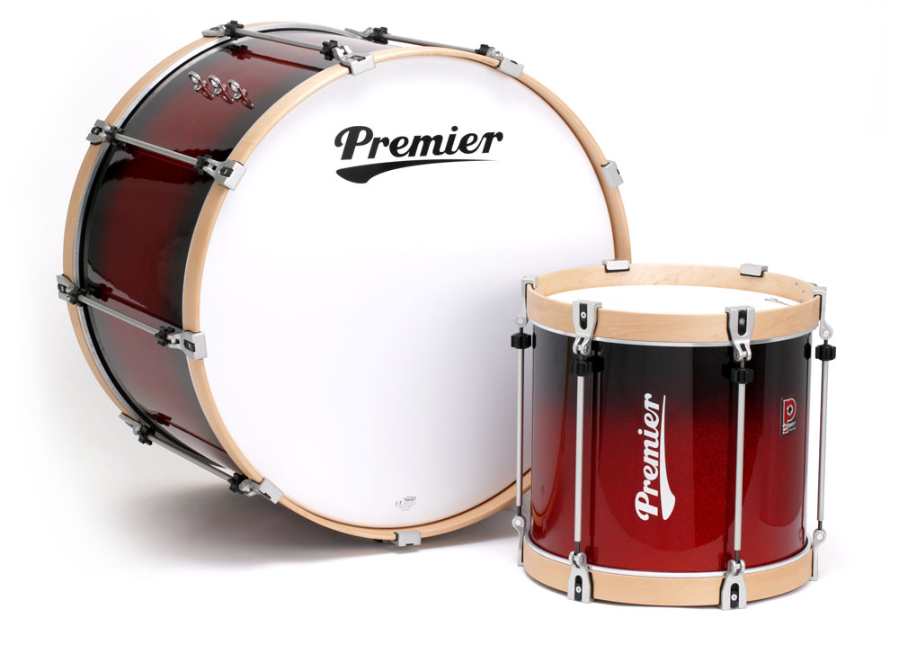

_____________________________________________________________________________________

_____________________________________________________________________________________

_____________________________________________________________________________________

9. Look at the photograph of the living room below. (3 marks)



a) List something in the room that absorbs the most radiated heat.

_____________________________________________________________________________________

b) List something in the room that reflects the most radiated heat.

_____________________________________________________________________________________

c) List something in the room that emits radiated heat.

_____________________________________________________________________________________

10. Label one wavelength on the diagram below. (1 mark)

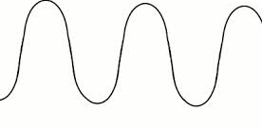

11. Draw a labelled diagram that shows how convection works in a pot of boiling water.
(4 marks)

12. State the unit used to measure frequency. (1 mark)

_____________________________________________________________________________________

13. What is the type of wave demonstrated in the diagram below? (1 mark)

_____________________________________________________________________________________
